**DETECTING PARKINSONS DISEASE USING MACHINE LEARNING**

**ASSIGNMENT - 4**

|  |  |
| --- | --- |
| Date | 4th October 2022 |
| Team ID | PNT2022TMID27836 |
| Student Name | Subha Madhav M S (311519104058) |
| Domain Name | HealthCare |
| Project Name | Detecting Parkinsons Disease using Machine Learning |
| Maximum Marks | 2 Marks |

# 1.)IMPORT THE REQUIRED LIBRARIES

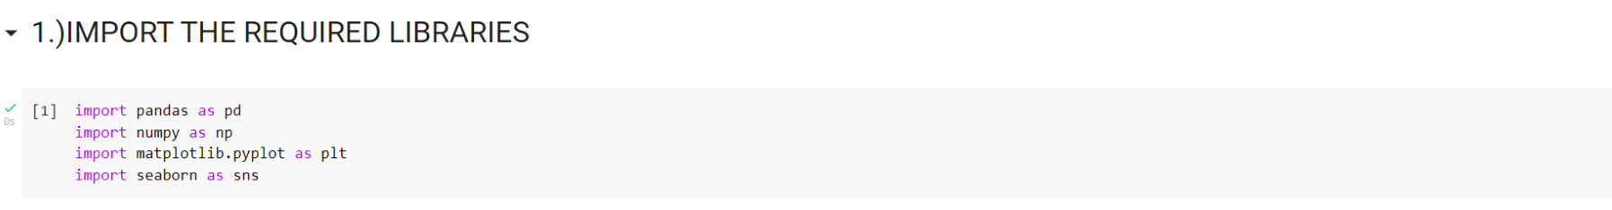

# 2.)DOWNLOAD AND UPLOAD THE DATASET

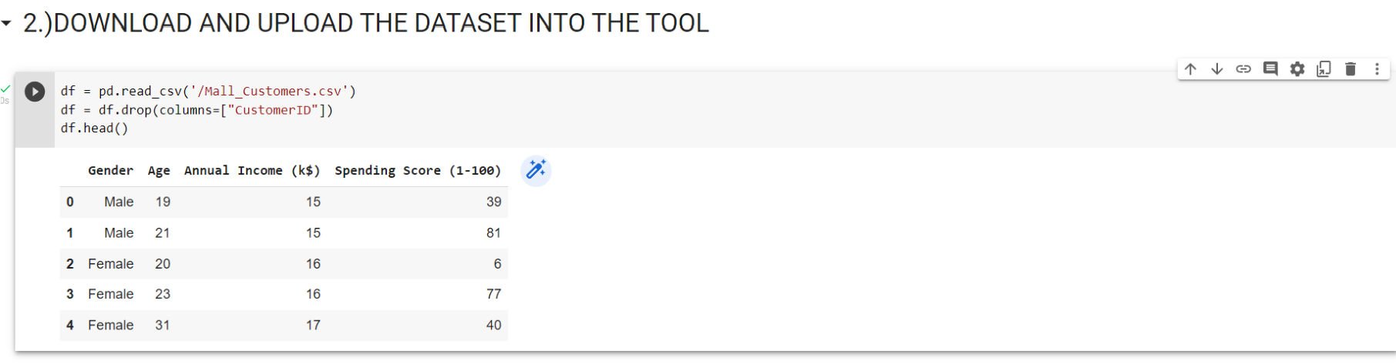

# 3.)HANDLE MISSING VALUES AND DEAL WITH THEM

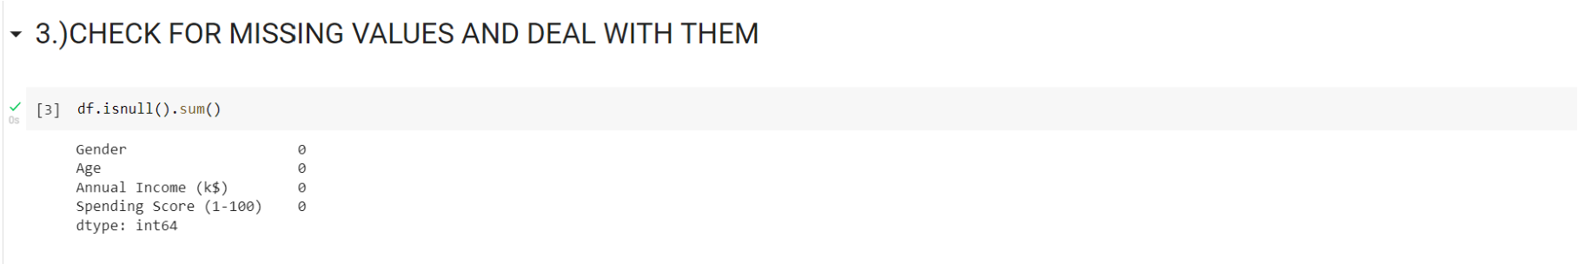

# 4.) PERFORM THE DESCRIPTIVE STATISTICS ON THE DATASET

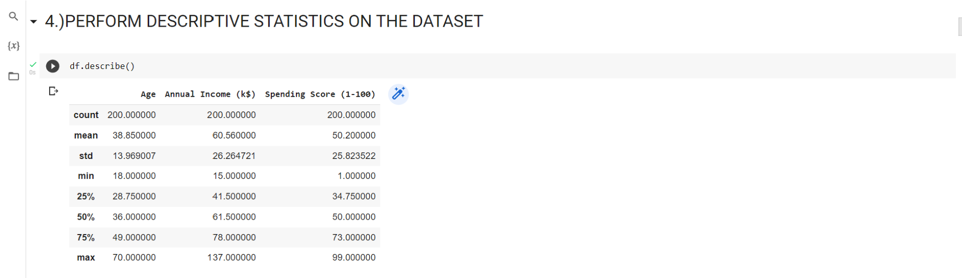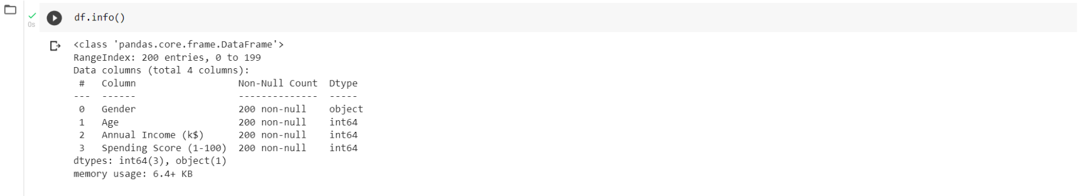

# 5.) PERFORM VARIOUS VISUALISATIONS a.) UNIVARIANTE ANALYSIS

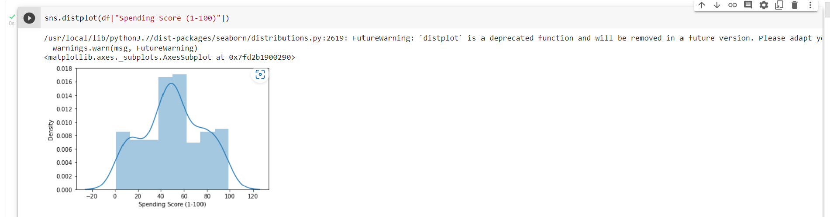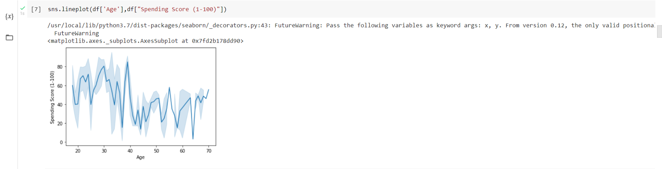

# b.) MULTI - VARIANTE ANALYSIS

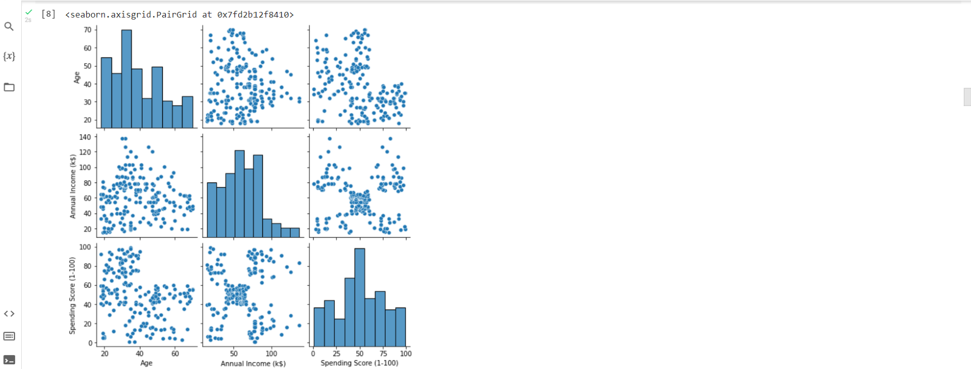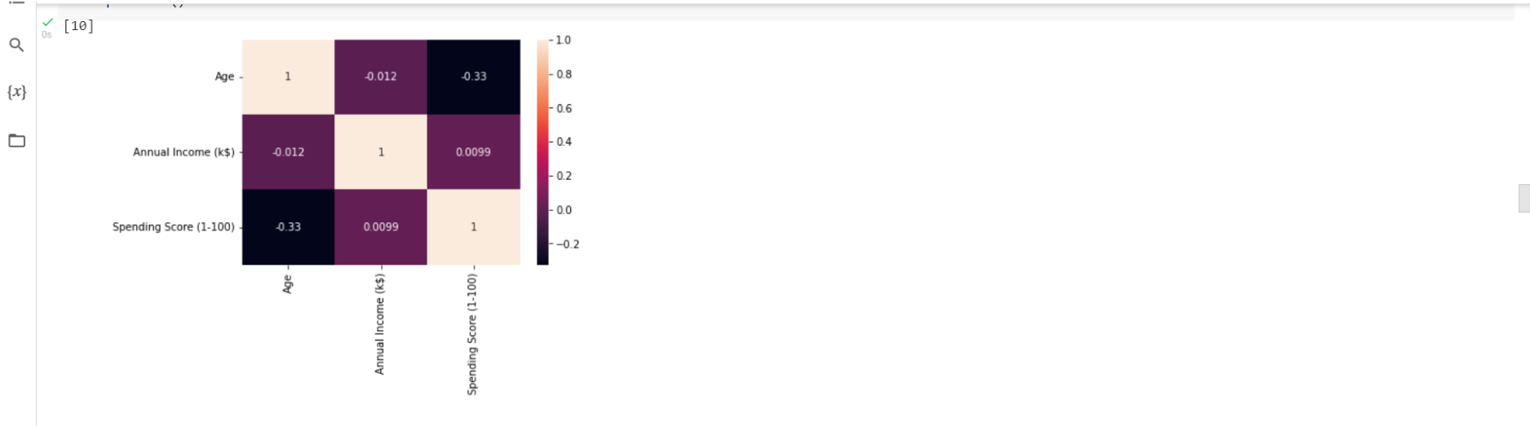

# 6.) FIND AND REPLACE THE OUTLIERS

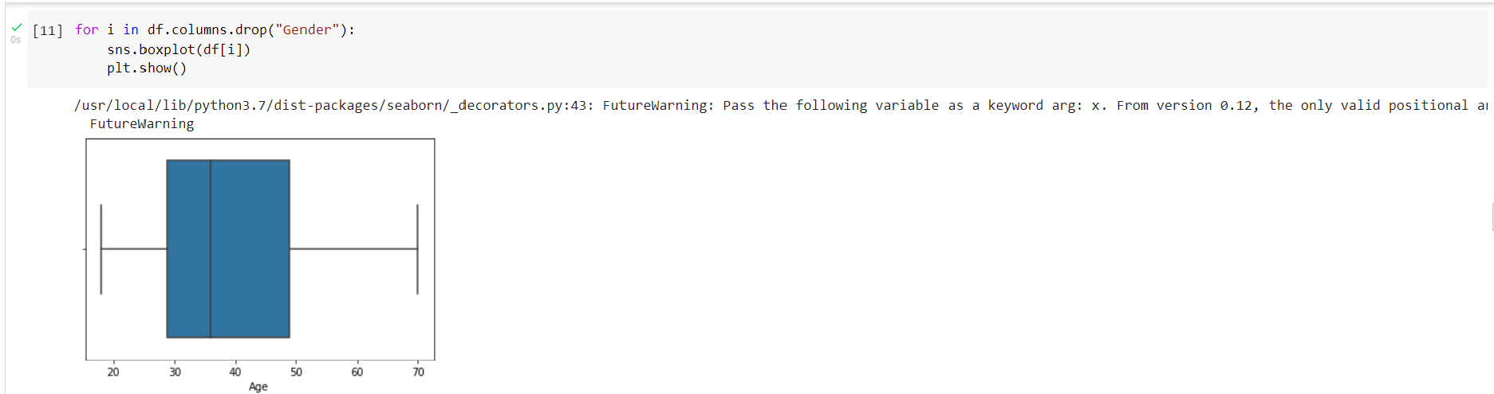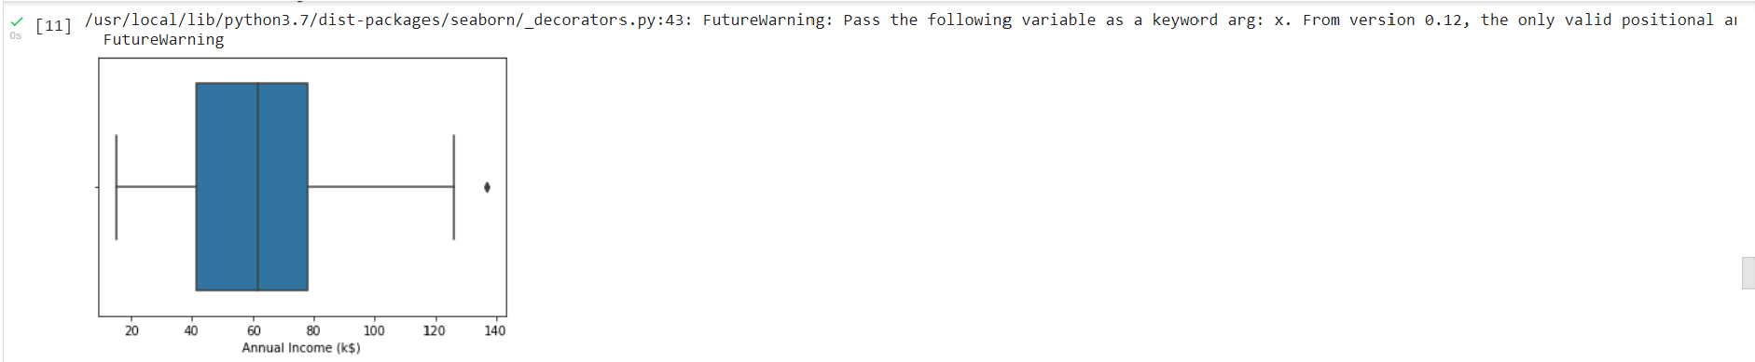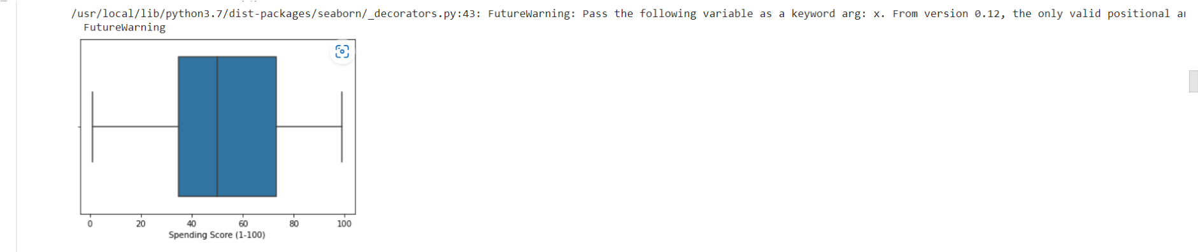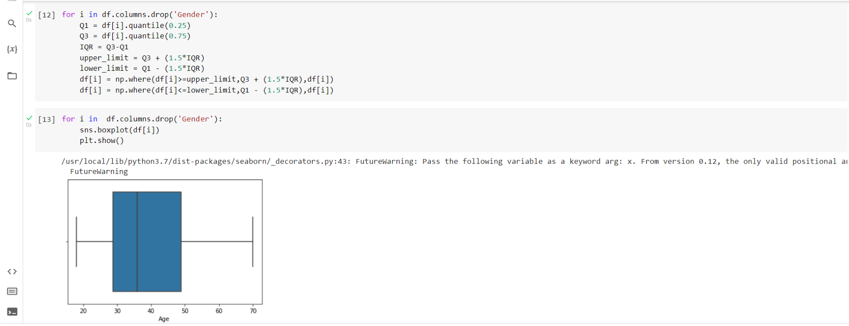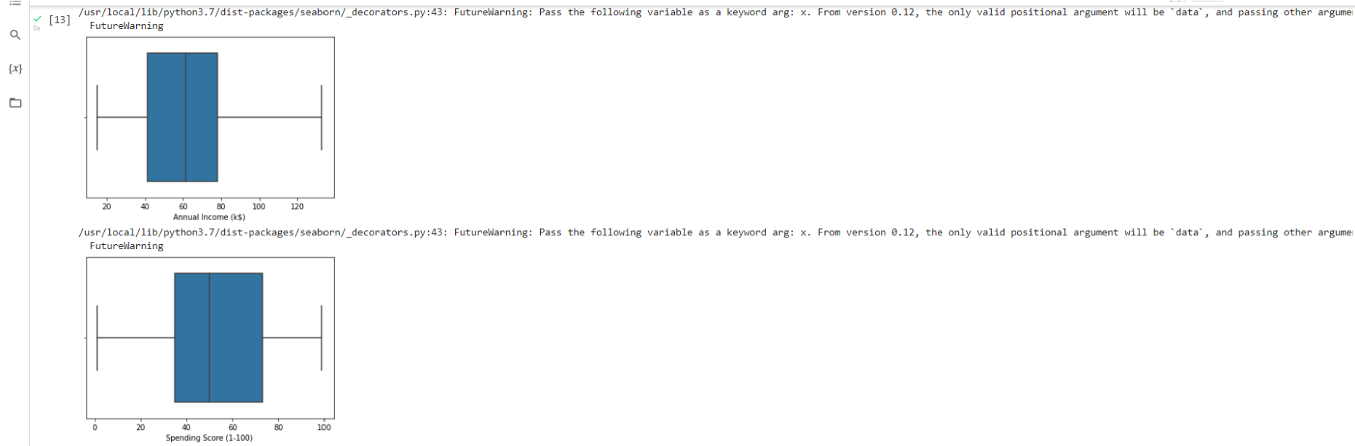

# 7.) CHECK FOR CATEGORICAL COLUMNS AND ENCODE THEM

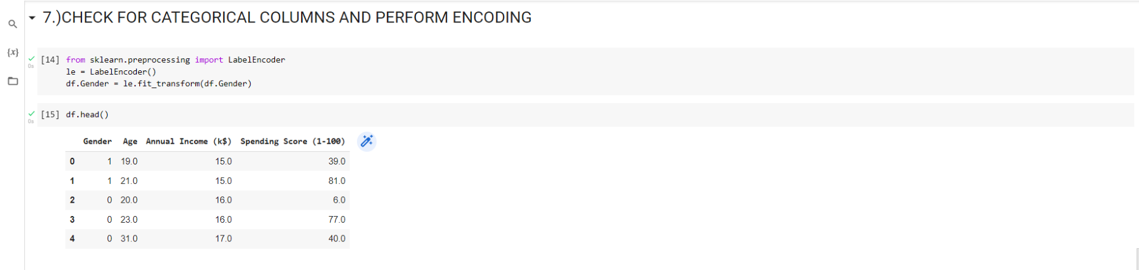

# 8.) SCALING THE DATA

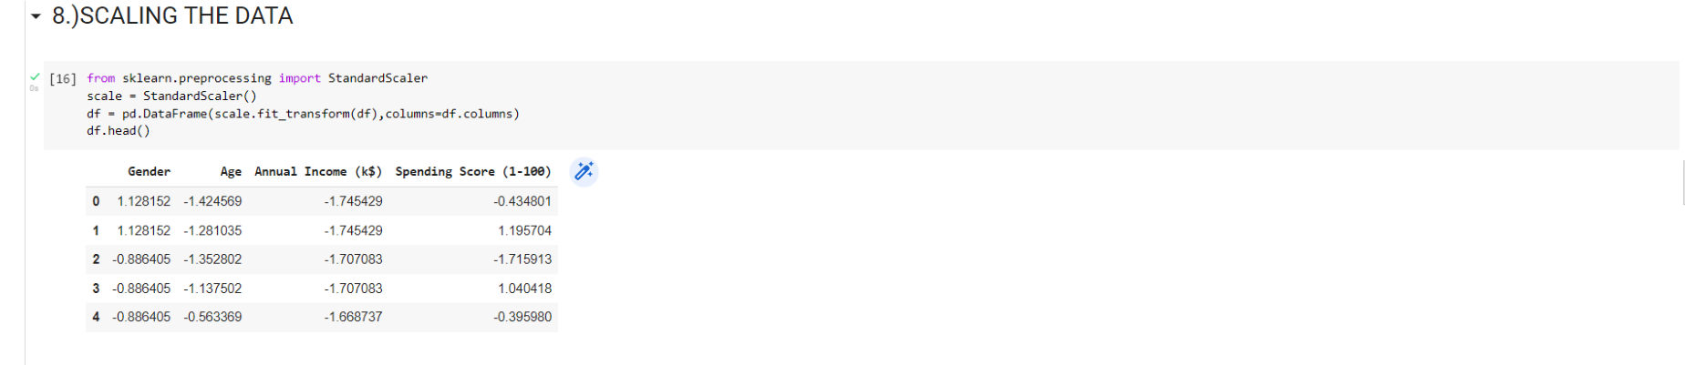

# 9.) PERFORMING ANY OF THE CLUSTERING ALGORITHMS

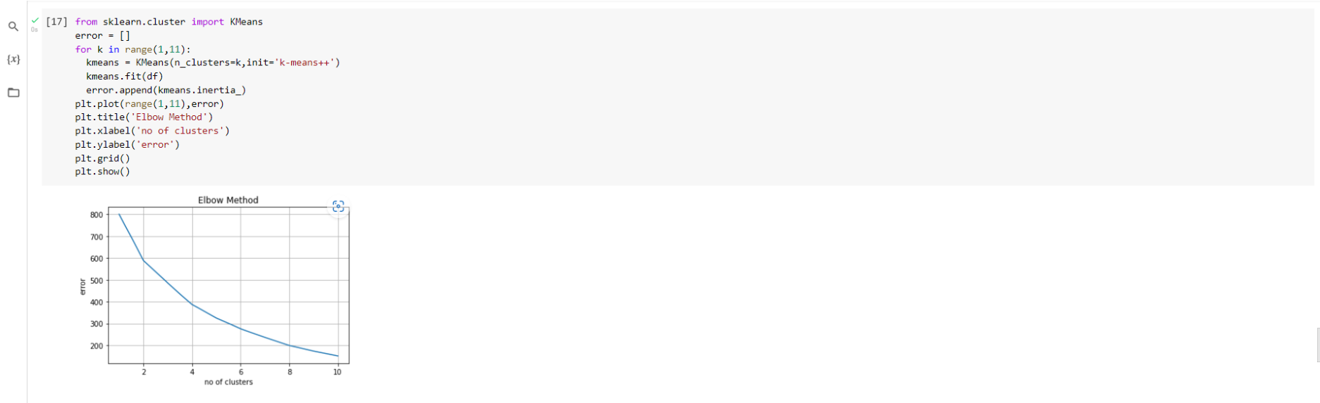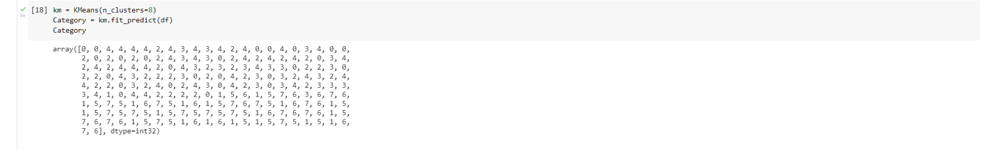

# 10.) ADD THE CLUSTER DATA WITH THE PRIMARY DATASET

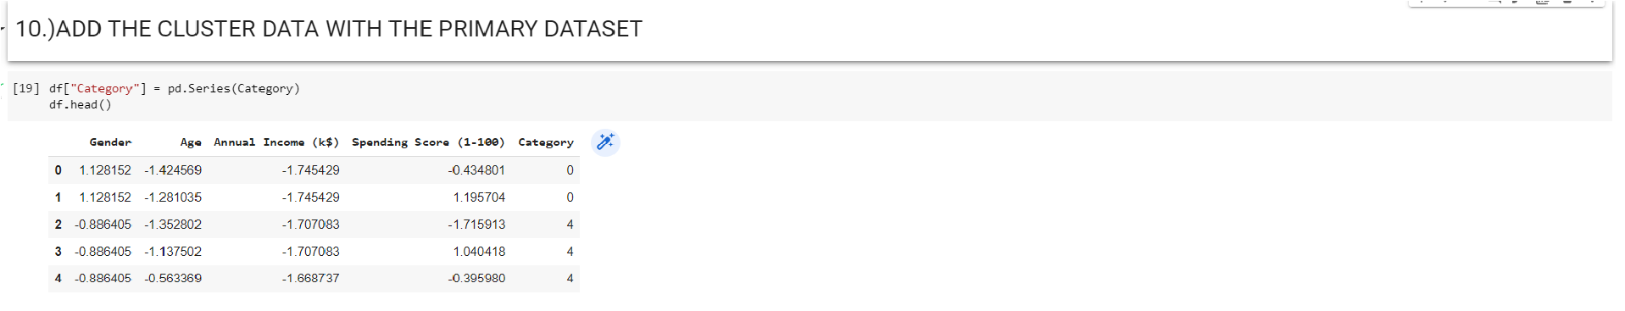

**11. )SPLITTING THE DATA INTO DEPENDENT AND INDEPENDENT**

# VARIABLES



# 12.)SPLIT THE DATA INTO TRAINING AND TESTING DATA



## 13.) BUILD THE MODEL



## 14.) TRAIN THE MODEL



**15.)**

**TEST THE MODEL**

**16.)**

**MEASURE THE PERFORMANCE USING METRICS**

